A000-Afr-Kongo-N’kisi-Kuba-Bwoom-Early 19th Century

Pygmy[1] Knowledge in Central Africa among the Kongo and Kuba Peoples

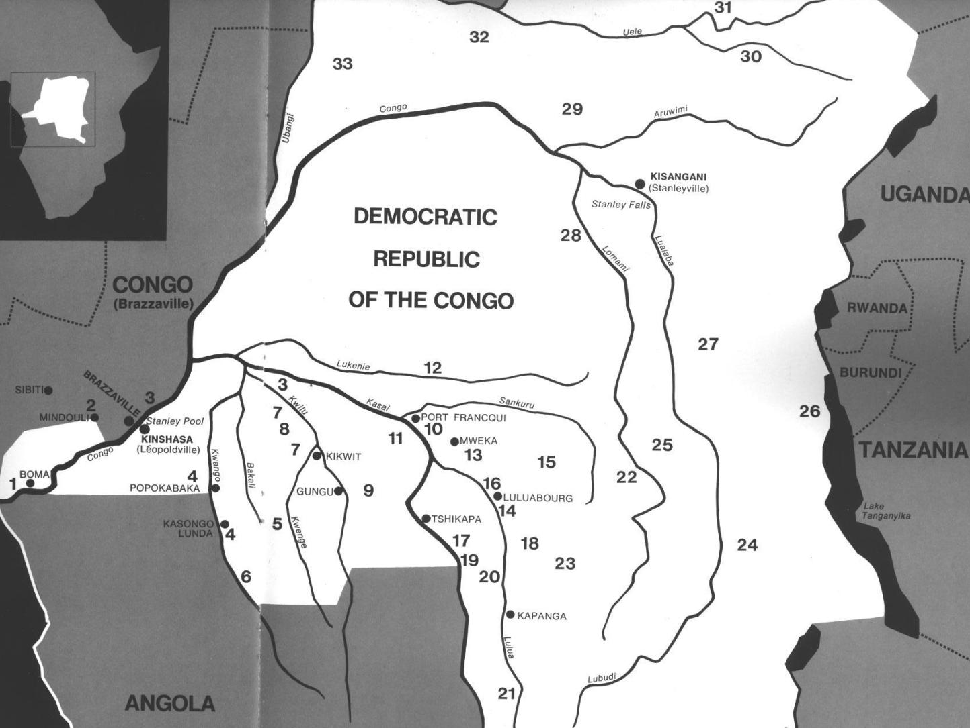

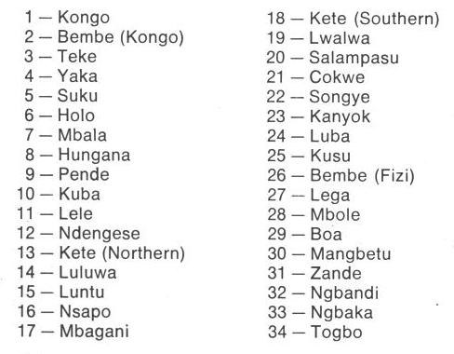

Fig. 1. Map of Kongo Cultures, West Central Africa. After Walker Art Center 1967.

Case 6-

Who are the Mbuti?

The Mbuti (more correctly, BaMbuti) live in 70,000 km2 of the Ituri Forest, in the northeastern Democratic Republic of the Congo (DRC), formerly Zaire. The Ituri River flows through this rainforest into the Aruwimi River and finally into the Congo River. The ca. 40,000 BaMbuti are comprised of the Efé, the Sua and the Asua. The Efé are the most ancient, having emerged from an ancestral Central African population ≈70,000 years ago (Quintana-Murci *et al*. 2008). The Katanda site on the Upper Semliki River in the Western Rift Valley was settled by the Ancestral Efé, who made bone harpoons which date to this period.

1. Three archaeological sites at Katanda on the Upper Semliki River in the Western Rift Valley of Zaire have provided evidence for a well-developed bone industry in a Middle Stone Age context. Artifacts include both barbed and unbarbed points as well as a daggerlike object. Dating by both direct and indirect means indicate an age of -90,000 years or older.
2. 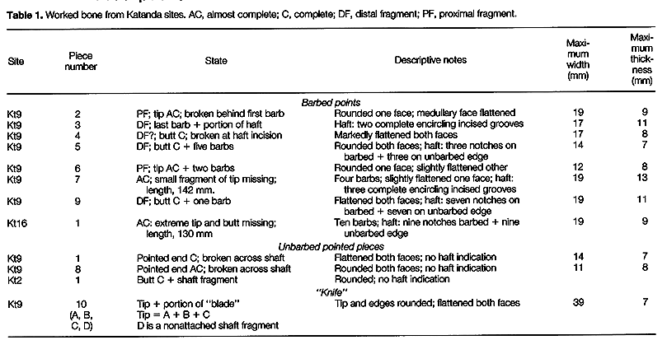
3. Together with abundant fish (primarily catfish) remains, the bone technology indicates that a complex subsistence specialization had developed in Africa by this time. The level of behavioral competence required is consistent with that of upper Paleolithic Homo sapiens sapiens. These data support an African origin of behaviorally as well as biologically modern humans.

The Paleolithic behavioral transition from Middle to Upper (in Europe, central Asia, Siberia, and the Near East) occurred ca 35 ka BP. This transition is coincident with the extinction of the Neandertals (*Homo sapiens neandertalensis*) and the predominance of *Homo sapiens sapiens*. Following this transition is the appearance of (i) new technologies, such as prismatic blade cores, specialized bone and antler tools, burins, and sophisticated hearths, (ii) more complex economic strategies, in-volving seasonally specific activities, stor- age, and long-distance procurement, (iii) larger scale social networks, reflected not only in the long-distance trade in raw materials but also in the use of personal ornaments, and (iv) an expanded use of symbols in art and daily life. In what follows we are primarily concerned with this fourth point.

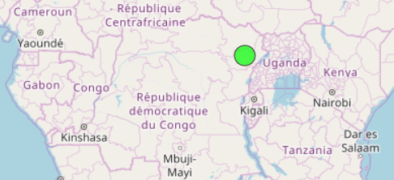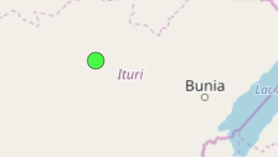

<http://glottolog.org/resource/languoid/id/efee1239.bigmap.html#4/1.88/29.29>

[http://glottolog.org/static/favicon.ico?v=9f3f8cd893876bfacc0f4dc9f16a9c19](view-source:http://glottolog.org/static/favicon.ico?v=9f3f8cd893876bfacc0f4dc9f16a9c19)"

The most important god of the BaMbuti pantheon is [Khonvoum](https://en.wikipedia.org/wiki/Khonvoum) (also Khonuum, Kmvoum, Chorum), a god of the hunt who wields a bow made from two [snakes](https://en.wikipedia.org/wiki/Snake) that together appear to [humans](https://en.wikipedia.org/wiki/Human) as a [rainbow](https://en.wikipedia.org/wiki/Rainbow). After [sunset](https://en.wikipedia.org/wiki/Sunset) every day, Khonvoum gathers fragments of the [stars](https://en.wikipedia.org/wiki/Star) and throws them into the sun to revitalize it for the next day. He occasionally contacts mortals through [Gor](https://en.wikipedia.org/w/index.php?title=Gor_(mythology)&action=edit&redlink=1) (a thunder god who is also an elephant) or a [chameleon](https://en.wikipedia.org/wiki/Chameleon) (similar to the divine messenger used by [Orish-nla](https://en.wikipedia.org/w/index.php?title=Orish-nla&action=edit&redlink=1) of [Yoruba mythology](https://en.wikipedia.org/wiki/Yoruba_mythology)). Khonvoum created mankind from [clay](https://en.wikipedia.org/wiki/Clay). Black people were made from black clay, white people came from white clay, and the Pygmies themselves came from red clay. He also creates the animals that are needed by hunters.

[Arebati](https://en.wikipedia.org/w/index.php?title=Arebati&action=edit&redlink=1) is a [lunar deity](https://en.wikipedia.org/wiki/Lunar_deity) and [Sky Father](https://en.wikipedia.org/wiki/Sky_Father). In some sources, he was said to have created humanity from clay, instead of Khonvoum.

[Tore](https://en.wikipedia.org/w/index.php?title=Tore_(mythology)&action=edit&redlink=1) is a god of the [forests](https://en.wikipedia.org/wiki/Forest) who supplies animals to hunters. He is also a thunder god who appears as a storm and hides in [rainbows](https://en.wikipedia.org/wiki/Rainbow). Most importantly, Tore appears as a [leopard](https://en.wikipedia.org/wiki/Leopard) in the initiation rites. The first Pygmies stole fire from Tore; he chased them but could not catch them, and when he returned home, his mother had died. As punishment, he decreed that humans would also die, and he thus became the death god.

[Negoogunogumbar](https://en.wikipedia.org/w/index.php?title=Negoogunogumbar&action=edit&redlink=1) is a child-eating [giant](https://en.wikipedia.org/wiki/Giant_(mythology)). [Obrigwabibikwa](https://en.wikipedia.org/w/index.php?title=Obrigwabibikwa&action=edit&redlink=1) is a [dwarf](https://en.wikipedia.org/wiki/Dwarf_(mythology)) who can change himself into a [reptile](https://en.wikipedia.org/wiki/Reptile).

A BaMbuti [soul](https://en.wikipedia.org/wiki/Soul) is called a megbe. When a man dies, his son places his mouth over his to draw in part of the *megbe*. Another part inhabits the man's totem animal. If the son doesn't inhale the *megbe* or the totem animal is later killed, it may escape into the forest, where it becomes a semi-visible being called a *Lodi* and lives forever with others like it.[[1]](https://en.wikipedia.org/wiki/Mbuti_mythology#cite_note-1)

**1. Pygmy Knowledge in the Kongo Kingdom.**

Around 1100 AD**/**CE Ntinu Lukeni (or Weni, son of a local king) in the Bantu Kongo-speaking Vungu (Bungu) Kingdom on the north bank of the Congo or Nzadi River (a truncation of thr KiKongo *nzadi o nzere*, "river swallowing rivers" (Forbath 1977;19), invaded the south bank of the river in order to establish a new Kongo speaking Kingdom. There he established a system of tariffs along the river charging traders to transport their goods. He also began requiring the local inhabitants to speak the Bantu Kongo language. He established a series of treaties with local chieftains so that his men would marry their daughters ensuring loyalty to his hegemony. Among these peoples were three groups of diminutive aboriginal inhabitants or Pygmies: BaMbaka-mbaka, Mbwidi-Mibodila and BaFula Mengo. These were characterized by the Kongo as having hydrocephaly (large heads), which physically and symbolically referred to their perceived knowledge of the riches of the forests in which they lived and the medicines they derived from local plants. This esteem for Pygmy knowledge was observed at the courts of Mbanza Kongo and Loango where the King of the Kongo entertained the chief medical specialists of the Kingdom who regarded these diminutive aboriginal inhabitants of the Kingdom as, in fact, Pygmies.

**2. Connection of the Kongo People with the Kuba-Bushongo (Bushoong)**

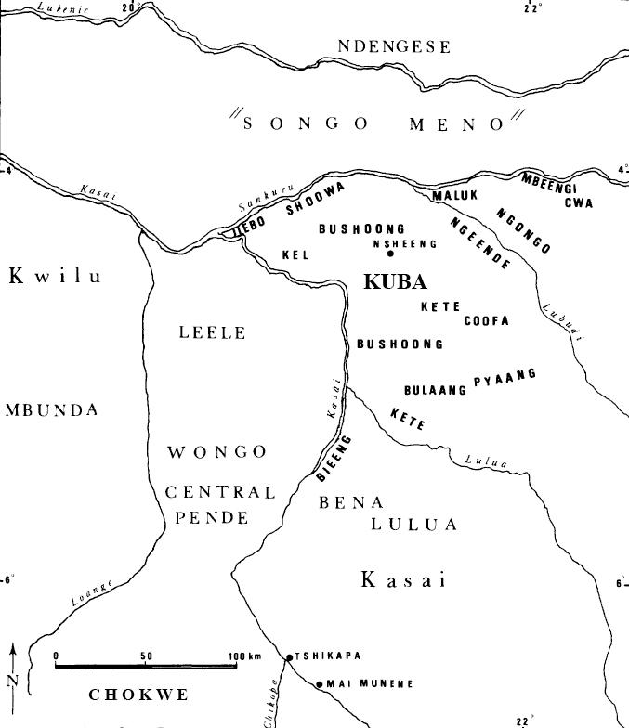

Fig. 2. Kuba territory with tribal groups in bold typeface (after Brett-Smith 1983).

The Kuba peoples to the east of the Kongo peoples also had contact with these “Pygmies” as well. They recognized the superior knowledge that these people had of the riches of the rain forest and therefore they ensconced them as a prominent feature of their culture. Tradition relates how a Kuba woman carved a face on a calabash that became the original model for initiation masks. Later, the invention was adopted for male initiation rites, and today remains a male privilege. Once masked, the Kuba dancer assumes the persona of the spirit of the mask as its apotheosis (cf. Torday 1910:250; Vansina 1955:140).

The Kuba have three royal mask types: 1) ***Mwaash a Mbooy***, representing Woot and the king; 2) the wooden face mask, ***Ngady Mwaash a Mbooy***, the incestuous sister-wife of Woot; and 3) the wooden helmet mask, ***Bwoom***, the Pygmy, also the challenging brother and the common man. These characters appear in a variety of contexts including public ceremonies, rites involving the king, and initiations. Although their dances are generally solo, together the three royal masqueraders re-enact Kuba myths of origin (Cornet 1982:254,256; Roy 1979:170).

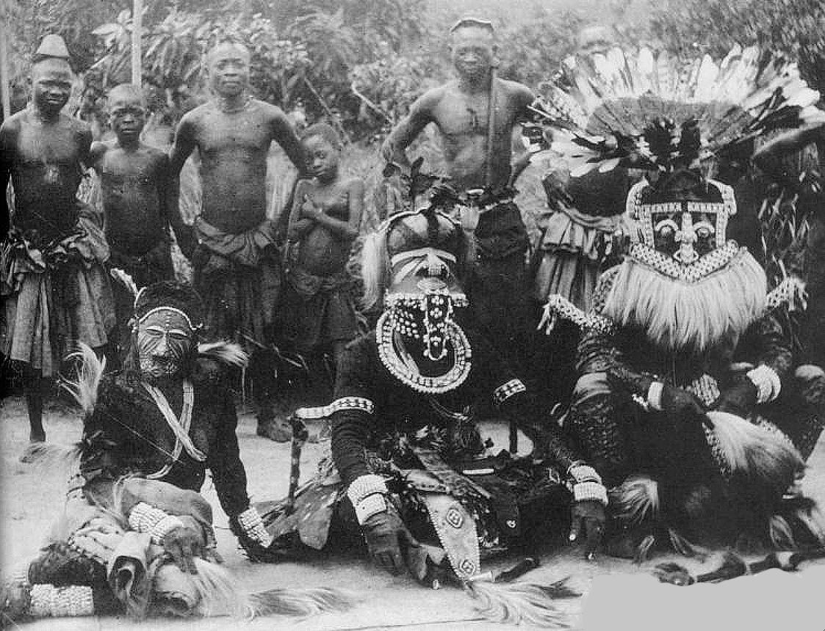

Fig. 3. Kuba masqueraders, Nesheng, southern Kasai River, 1909. Royal Kuba Masqueraders, Nsheng, Kasai, Congo, 1909 (after the Library of the University of Michigan, Image 344206, http://quod.lib.umich.edu/h/hart/x-344206/03d100403). ***Bwoom*** masquerader, front, center, of hydrocephalic (large-headed) aboriginal pygmy symbolizing profound local knowledge of the forest and its medical riches. Front-center, right: ***Mwaash aMbooy***, representing Woot, the founding ancestor of the Kuba. Front–center left: ***Ngady Mwaash aMbooy***, the incestuous sister-wife of Woot.  
  
The *Bwoom* mask proper dates to the early eighteenth century. A royal mask attributed to King Miko mi Mbul dates to ca. 1800-ca. 1835 (Cornet 1975: no. 63, p. 89). An eighteenth-century song for the son of King Kot aNce refers to the first recorded instance of adorning *Bwoom* masks with cowries and beads., implying that earlier masks were devoid of these accoutrements at signified wealth. Many variations of the mask evolved perhaps from prototypes (Vansina 1978: 216).

A000-Afr-

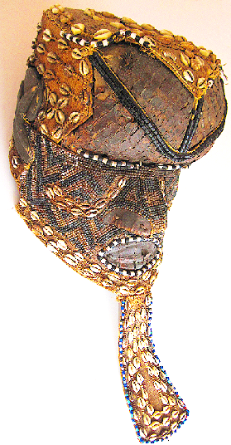 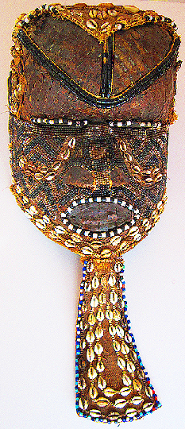 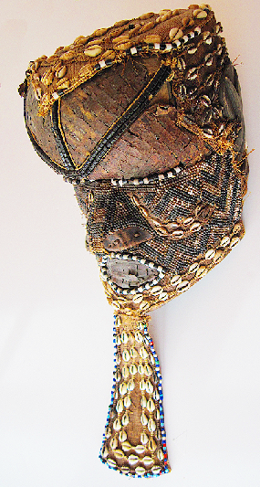

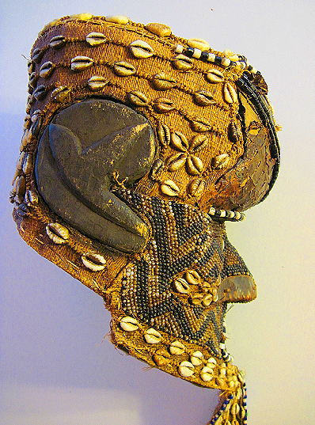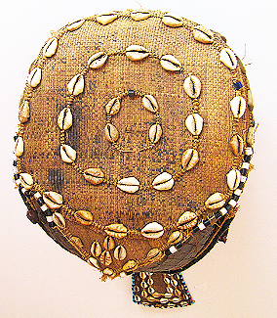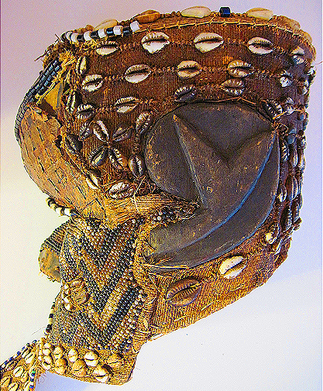

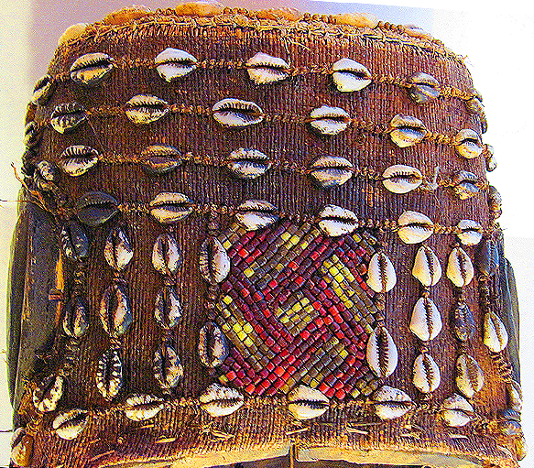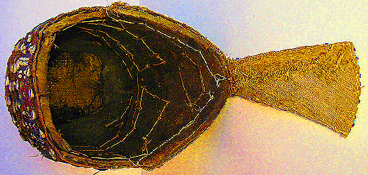

Fig. 4 a-b. *Bwoom* helmet mask, Kuba-Bushongo-Bushoong; Democratic Republic of Congo, Atlantika Collection. Wood, hammered copper, raffia fiber, animal skin, cloth, beads, cowrie shells. This large, proportioned, hollow wooden mask probably dates to the early twentieth century. The perimeter, temples, pate and back are decorated with beads and cowrie shells (used in the area as currency). A pendant “beard” has cowry shells surrounded by beads. The broad face has an incised zigzag motif similar to the geometric keloid scars that are applied to the Kuba body and which are replicated in textile designs (Cornet 1982:266; see Fig. 3). In this example, the carved wood understructure is covered with copper sheeting that is extended by a beard made of hide and accented throughout by beadwork. Beads also embellish the contours of both the eyes and the mouth. A series of bead bands crosses the surface of the face, one from the crown of the head to the tip of the nose and another from one side of the head to the other, bisecting the eyes.The cheeks are outlined with dual bands of cowry shells, and the crown is covered with animal skin surmounted by three bands of two strand ancient beads.

The *Bwoom* mask has three aspects: 1) as a Pygmy, 2) as a challenging brother, and 3) as a common man.

1) The *Bwoom* as a Pygmy. The Pygmies are forest-dwelling, hunter-gatherers and know this seemingly impenetrable landscape intimately. The ancient idea that a society's landscape is its own because its ancestors are buried there is central to Pygmy cosmology. The Kuba recognized this ancient idea. When they migrated into Pygmy forests they realized that their hope of a successful life in this landscape was to ally themselves with the Pygmies and learn the Pygmy lore of the ancient ancestral forest spirits (cf. Ehret 2002:50; Schadeberg 1999). Appropriately, *Bwoom* is the first spirit seen as an apotheosis by *nkan* initiates.

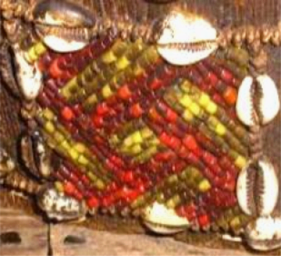

Fig. 7. Right-handed Swastika design at the back of the head on the Atlantika Mboom mask.



Fig. 6. Kuba Shoowa woman with keloid scars that suggest a connection with a Bwoom mask (after http://www.ezakwantu.com/Kuba%20Shoowa%20Scarifacatoin%200001.jpg )



Fig. 5. Kuba woman with a geometric textile design similar to the zig-zag keloid scars of the Pygmy (after www.ezakwantu.com.)

2) The *Bwoom* as the challenging brother. This aspect of the *Bwoom* invokes a ritual reenactment of the struggle for social power of the challenging brother who seeks both the throne of his brother, *Mwaash A Mboy*, and the king's wife, *Ngaady A Mwaash*. *Bwoom*, therefore, supports the challenge of authority.

3) The *Bwoom* as the common man. This role of the *Bwoom* fostered the respect of the individual's rights and the need for consensus among commoners as necessary checks and balances to offset royal authority.

Two traditions trace *Bwoom*'s origin to the problem of royal succession: King Miko mi-Mbul killed the children of his predecessor so that he could succeed to the throne. However, he subsequently went mad. (Even today the issue of royal succession is critical to West and Central African peoples as the slaughter at Yendi in northwestern Ghana illustrates in 2004 when the king of Yendi murdered the offspring of his rival in Tamale.) Although King Miko mi-Mbul eventually regained sanity, he would lapse into madness each time he wore the *Mwaash a Mbooy*, the sole royal mask. A Pygmy, an outsider who by his small stature was considered even less a force than a Kuba commoner, offered the king a *Bwoom* mask as a gift, and Miko accepted it. Its effects were profound, yet covert. With the *Bwoom* mask the king became like those whom he had previously despised. He learned empathy. Another version is that King Miko mi-Mbul, who was known as a great dancer, was seduced by the Pygmy’s mask because the King Miko mi-Mbul danced with it so well in the rites, despite its overtly humble character. The king was able to enter the soul of the commoners and therefore perceive their innermost desires for a just rule. In order to soften the critique of royal malfeasance, in both versions the King is reputed to have made alterations to the mask that justified its inclusion in the royal repertoire (Cornet 1982:269). These accounts reify the need for royal power to be circumscribed (literally) by commoners "of low standing scarcely worthy of being embodied by the king" (Cornet 1975: 89). The defiant performance of *Bwoom* opposes the regal *Mwaash a Mbooy*. The two act out a competition for one female in the royal mask trio, *Ngady mwaash aMbooy* (Cornet 1982:255). Mwaash aM-booy's dance is calm, stately and without passion, while *Bwoom* acts with pride and passion (Cornet 1982:255). Materially, the masks are easily differentiated by material, for *Bwoom* is carved from a single piece of wood by male artisans and *Mwaash a Mbooy* is woven by women from textiles. Here a tension and quasi contradiction is implicit: commoner men manufacture the mask of commoners and women ostensibly the consorts of the king manufacture the mask of royalty. *Bwoom* appears apotropaically on the *nkan* or "initiation fence" of the Kuba, prohibiting entrance to all not in the rite (Vansina 1955:150-151). *Bwoom* does not appear at funerals and is never interred with the king or other dignitaries because it is the spirit of the living commoners not of the king (Cornet 1982:270). The costume is similar to that of *Mwaash a Mbooy*: heavy with profuse layers of raffia-cloth, bead and cowry decoration, leopard skins, anklets, armlets, and fresh leaves. Eagle feathers or other prestigious media are added to the crown of the head when the mask is danced.

**3. Kuban Kings as Ndop Sculptures Communicating with the Pygmies**

In addition to the Kuban masks there is also a tradition of idealized effigy sculptures of Kuba kings. Praised as "God on Earth," the king, *nyim*, is a divine ruler who controls fertility and communicates with   
*Mboom*, that is, the knowledge of natural resources provided by the Pygmys.

*Ndop* figures are idealized portraits of individual Kuba rulers. The *ndop* ruler sits cross-legged on a raised platform. His demeanor expresses both aloofness and composure. The belts, armbands, bracelets, shoulder ornaments, and special projecting headdress are all elements of royal regalia. *Ndop* figures were believed to represent and honor the spirit of the *nyim* and serve as a point of contact with his spirit.

The royal court at Nsheng is a hierarchical complex of councils and titled officials who advise the king and balance his power. Outlying Kuba chiefdoms are largely autonomous, organized on models analogous to those of the capital but on a lesser scale (Vansina 1964:98-99; 1978:216). Kuba society parallels governmental organization in that it is stratified. Yet the Kuba people prize individual hard work and achievement, and while one’s position of birth may secure advantage, it is not binding (Vansina 1964:188;1968:13,15).

Most Royal sculptures are modern renditions carved during a ruler’s lifetime and finally placed near the dying king to receive the royal power, which would then be transferred to his successor. The earliest examples show the workmanship of a few artists who had developed a stylistic convention that was able to serve many regents. In time these figures with carefully executed details seen in the carefully shaped headdresses and bodies degenerated into cruder examples without fine details. The following two examples reflect this transition from carefully controlled atelier figures to cruder examples.

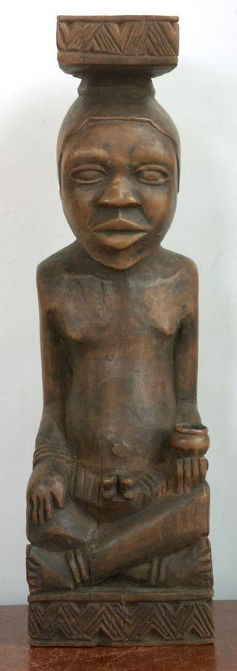 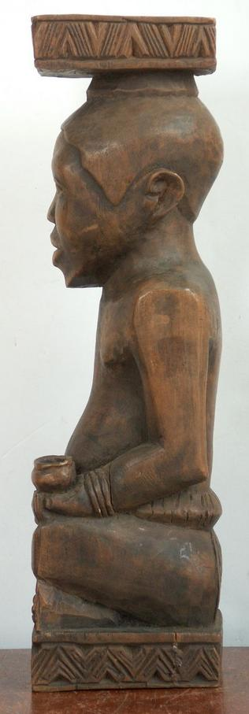 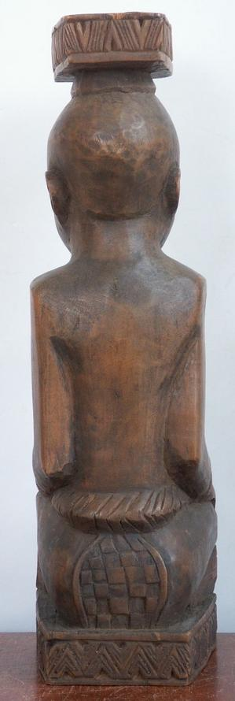

Fig. 8 a-c. Kuba Royal sculpture, earlier example with fine details. Height: 12.25x3.75x3.5 inches. Weight 2.1 pounds (960gm), ca. early 20th century. Atlantika Collection. In the left hand a small cup possibly containing a *bilongo* substance suggests that this king was also a *nganga’a n’kisi* or medical specialist.

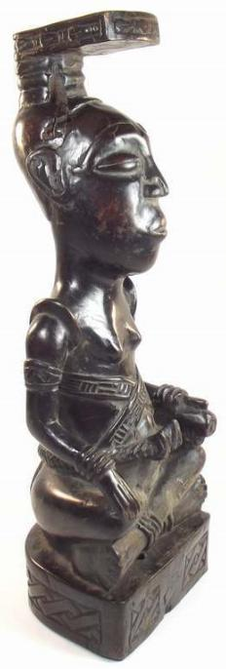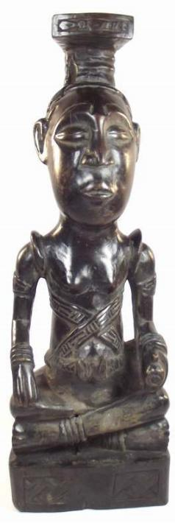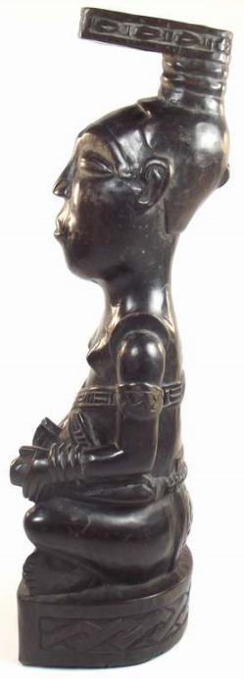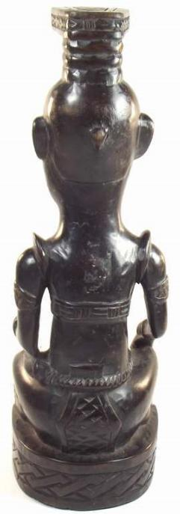

Fig. 8 a-c. Kuba Royal sculpture, later example, ca. mid 20th century. Atlantika Collection. The short sword in his left hand held with handle out, indicates the non-aggressive posture of the *nyim*.

**4. The Kongo Incorporate Pygmy Knowledge into Their Min’kisi**

In at least two impressive Royal locations the BaKongo recognized the medical contributions of Pygmy lore by their own specialists: Mbanza Kongo and Loango. In order to incorporate pygmy expert medical knowledge into BaKongo culture, Ntinu Lukeni married the daughter of a local pygmy (?) spiritual leader, Manikabunga, established the town of Mpemba Kasi (near the modern village of Matadi in the Kwilu valley), where the original Kongo Kingdom rulers would be buried, and he initiated the tradition of using pygmy (?) medicines (*bilongo*) in conjunction with miN’kisi which therefore may have had their origins with Manikabunga.

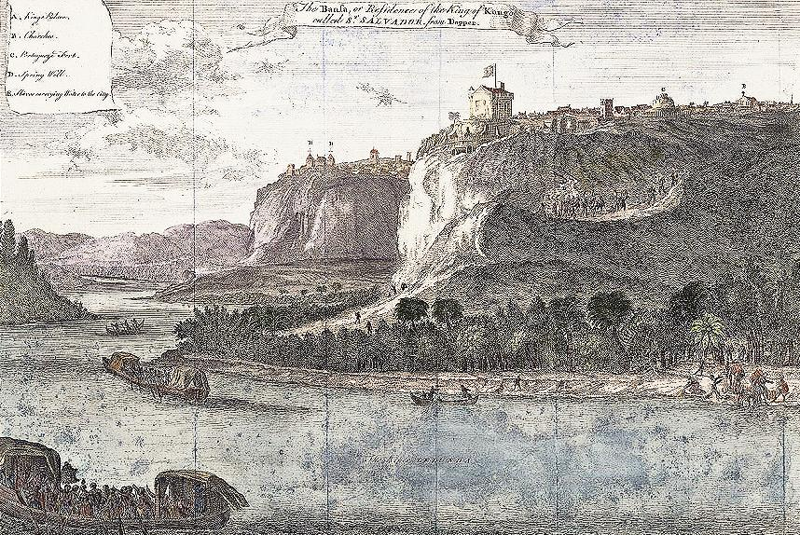

Fig. 5. Mbanza Kongo, “The Bansa or residence of the King of Kongo called Ste. Savadore [by the Portuguese] from [Olfert] Dapper [, *Description de l’Afrique* (Amsterdam: W. Waesberge, Boom et Van Someren, 1686)] where the Kingdom’s medical specialists, *nganga* or *ngang’a n’kisi* gathered to assess and confirm local pygmy knowledge. The Nzadi or Congo River in the foreground shows two laden trade vessels.

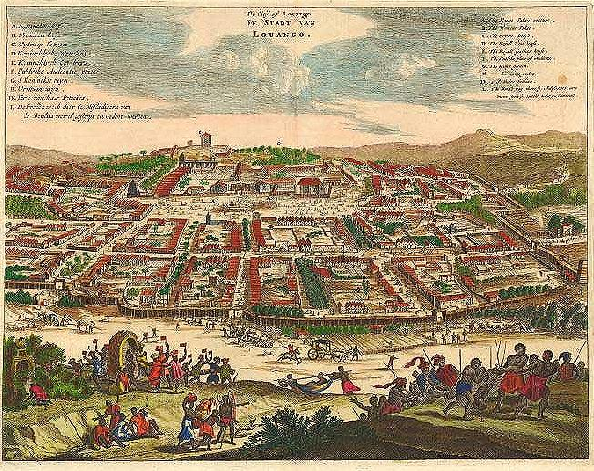

Fig. 6. "The City of Lovango [sic., Luoango], De Stadt van Luoango." After Olfert Dapper *Umbständliche und eigentliche Beschreibung von Africa* (Amsterdam, 1670). Another important city of the Kingdom of the Kongo, where medical specialists, *nganga* or *ngang’a n’kisi* gathered to assess and confirm local pygmy knowledge.

**5.The Kongo people incorporate Pygmy Knowledge into their *Nkisi***

*N’kisi* can take many forms such as baskets, pots, snail shells, as well as statuettes. In practice, a priest (*nganga’a n’kisi)* acts on behalf of the individual client to prepare the *n’kisi* to accept its medicines, the *bilongo,* that make it an active agent. Then the client tests the effective potency of the elements in the *bilongo* in actual experience of them with the intermediary of the *nganga* and is cautioned to avoid their powers.

In addition, the client must also attain a unification with the power of the *n’kisi.,* This may be accomplished through the application of pigments (often white and red) to the skin that establish a physical connection between the client, the metonymic colored pigments of the powerful dead and the pigments on the *n’kisi* sculpture (MacGaffey 1986: 139-141). White pigment derived from Kaolin or white clay (*mpemba*) signifies “land of the dead” or “cemetery” and is found in streambeds and corresponds to the belief that “the dead live in or under the water and are white in color”. Another important pigment is red ochre (*nsadi*) “also associated with the dead’ and implies “transition” from one state of being to another, i.e., from death to life (Van Wing 1959: 206 as cited by MacGaffey 1986: 140). At the same time through the actual physical application of red and white pigments to the skin, the client establishes a direct connection with the active agency of the ancestors. On the one hand, the effective potency of the contents of the *bilongo* can be discouraged, since these active agents may have been responsible for the difficulty in the first place. On the other hand the physical application of pigments to the skin may invoke healing by invoking the metonymic power of the ancestors (MacGaffey 1986: 141).

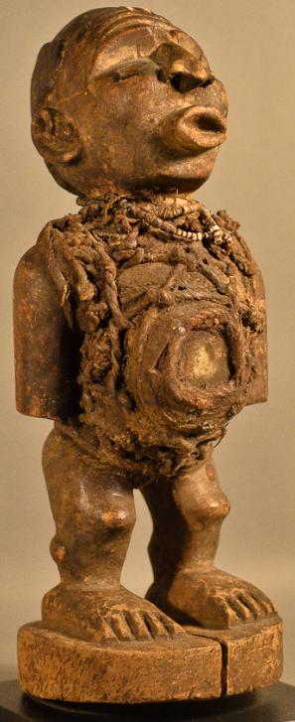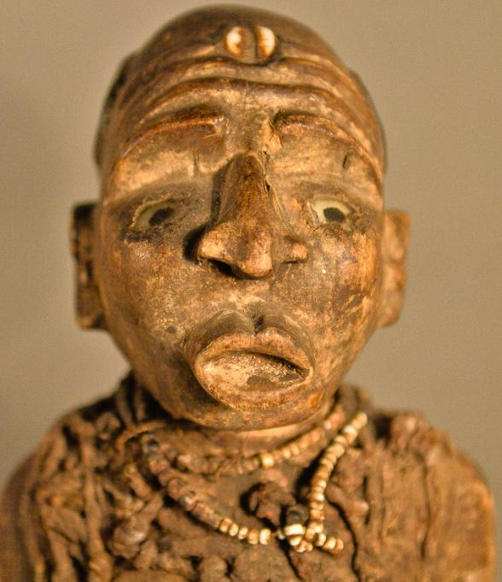 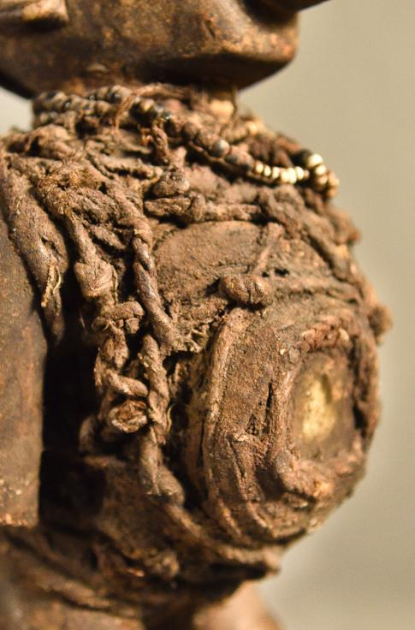 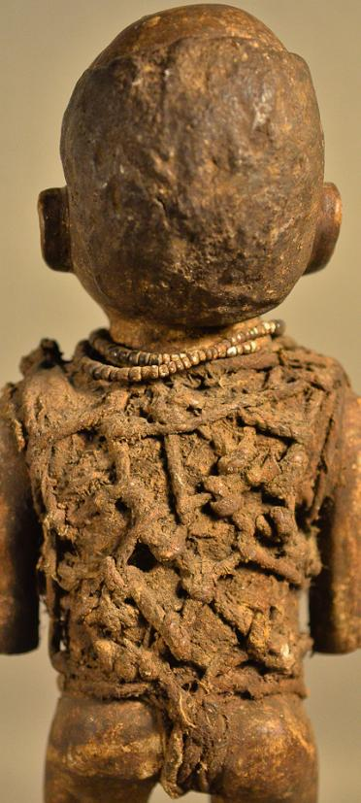

Fig. 7 a-d. *N’kisi*, BaKongo people, Democratic Republic of the Congo, 19th cent., wood, fiber, beads, and leather, Atlantika Collection.

This *n’kisi* (Fig. 7 a-d) is a wooden sculpture with the physical attributes of beads, fibers holding a medicine sachet containing mysterious, and unseen medicinal paraphernalia. All *n’kisi* are inanimate and powerless until they have been activated by a specially prepared medicine or *bilongo*. This *Nkisi* has a classic BaKongo face with expectant glass eyes and wrinkled brow (suggestive of the serious effort being exerted. Its forehead is adorned with a cowry shell or "*kodya"* in Kikongo, which evokes the word "*kola",* "to be strong", the exhortation of this powerful *n’kisi*, demonstrated by protruding lips and everted nose indicating the need for intentional breathing. Bent knees characterize all BaKongo sculptures indicating that this is an animate being and not a dead object. A protruding belly is the location of the most important feature since it is covered with *bilongo* objects -- wrappings of rope, roots and a leather pouch with a transparent crystal representing *kalunga*, "the watery threshold between the world of the living and the world of the dead". This pouch or sachet also contains other powerful but unseen, hence mysterious, objects such as efficacious insects and snake teeth). All of these unseen objects are affixed with secret types of knots securing these hidden objects with their mysterious powers to the body and by sympathetic magic to that of the patient. Its arms are at its side, showing attentiveness to the suppliant and are consistent with well-carved ears suggesting that it is ready to hear entreaties. A small, beaded, white, shell necklace is encrusted with libations after years of use (MacGaffey: 1988).

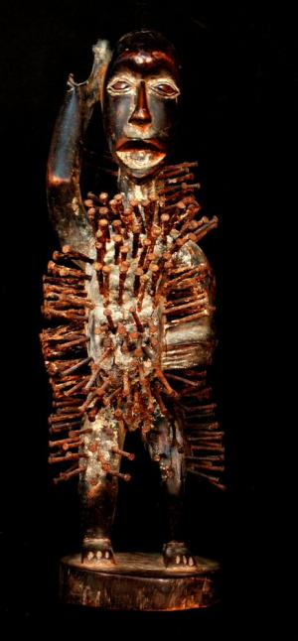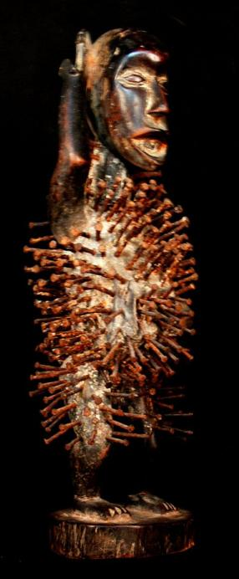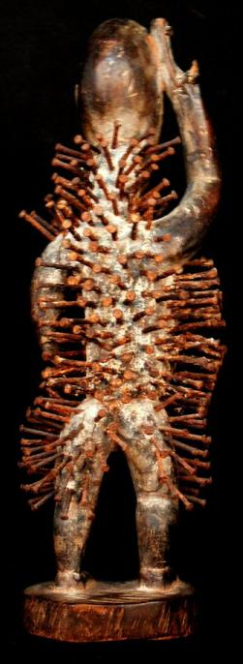

Fig. 8 a-b. *N’kisi nkondi*, BaKongo people, Democratic Republic of the Congo, 19th cent., wood and nails, Atlantika Collection. 12.20 inches high, Weight: 1.19 pounds.

The “Smasher” or “Lion” (Fig. 8a-c) is a kind of *n’kisi nkondi* “in which pieces of iron are often hammered into its surface commemorating the swearing of oaths and the concluding of alliances (Laman 1953, vol. 3, p. 86). This *n’kisi’s* construction follows the classic Kongo protocol. Bent knees signify it is an animate being activated by the *bilongo* or medicine that has been applied to it by the and not a dead object. Its posture signifies that it is actively communicating with the client and that has come to have the power to activate the. The partly open mouth or *bamuna* represents the vibrations that have the power to activate the breathing of the *mpungo* for the n’kisi is ready to speak and is open to the Sun.. The large eyes suggest that the power of *Kalunga* is present for Klunga speaks through the eyes and is ready to challenge (*mambo*) the client. The nails or *nkonso* embedded in the figure represent strongly felt commitments or agreements made by the *N’kis*i, a physical manifestation of an emotional event such as desires, requests for protection, defense and empowerment each sealed with a solemn vow or “tied *mambo*” (Thompson 1978).

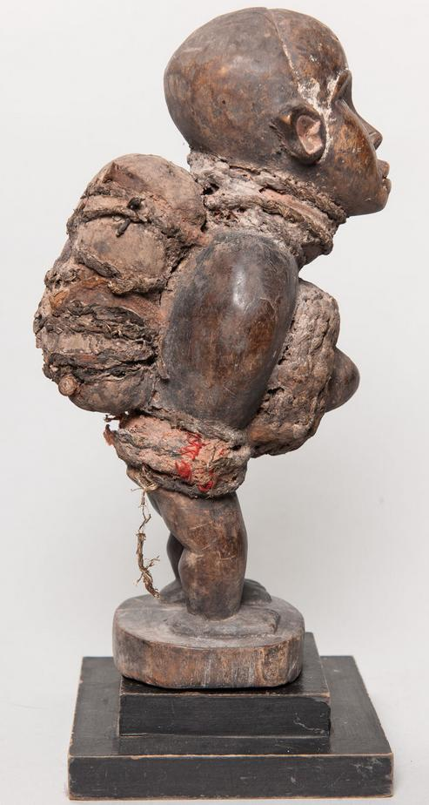 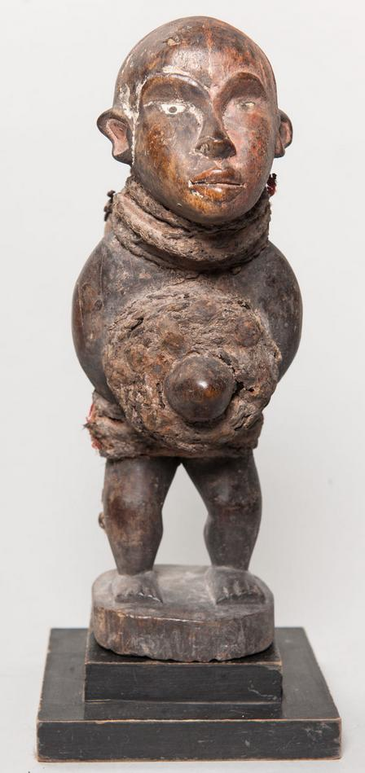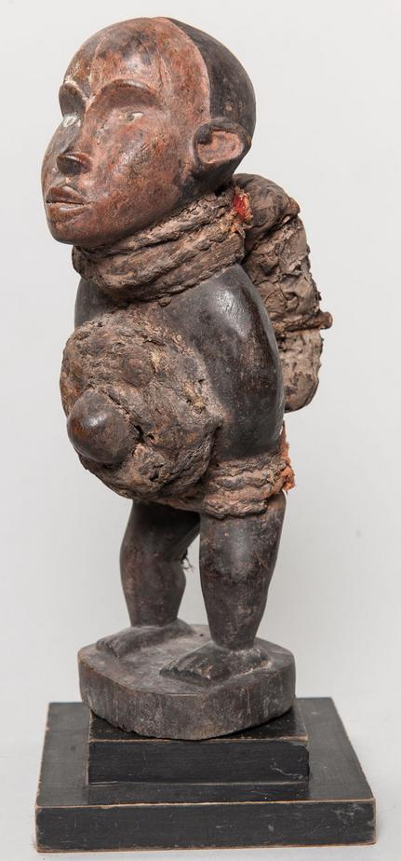

Fig. 9 a-b. *N’kisi nkondi mazita*, BaKongo people, Democratic Republic of the Congo, 19th cent., wood, fiber, beads, and leather, Atlantika Collection.

This particular *n’kisi nkondi mazita* uses knots called *mazita* (“tying up”) as a compilation of problems that are to be solved. The knot tying process involves slicing up palm leaves and tying them in knotted bundles on behalf of the “client” seeking solutions by the priest (*nganga’a n’kisi)*. Each client request of assistance and the acknowledgement of the request by the *nganga’a n’kisi* is recorded by each knot. In practice, knots have ten different forms according to Barbaro Martinez-Ruiz (2013:168-169).

1) Nkeka kanga-single knot signifies closure of a single issue

2) Mazita a tatu-several knots tied in a row signifyin difficult issues

3) Zeta seka kia kubula-broom like knot signifying spiritual cleansing

4) Zita lubamba-circularknots binding grass in a circle signifying completion

5) Seve kia lukamba-two knots in figure eight signifying restoration of goodwill with deceased

6) Zita dia vakika-reef knot tying two ropes together signifying tying multiple issues together

7) Zita dis kanga-butterfly knot ties along length of rope signifying silencing antagonisms

8) Simi dia ndala-cover usedto seal wine bottle signifying issues sealed temporarily

9) Zita a nkita-end of rope knotted to secure its strands signifying cure of illnesses

10) Nsoko wa diya-helix knot signifying three components: head (psychological issues). Upper torso (physical issues), lower body (ancestor isssues).

This *n’kisi* has ears that are carved as everted to hear the requests of clients and hopefully the *n’kisi* is capable of providing solutions as well!

**References:**

Adams, Monni. 1988. 8th century Kuba king figures, *African Art* 21(3): 32-38, 88.

Belepe, Bope. 1974. *Etude socio-morphologique des masques Bwoom des Kuba: Memoire de licence en histoire.* Lubumbashi: Université Nationale du Zaire.

Belepe, Bope. 1981. Les oeuvres plastiques Africaines comme documents d'histoire: Le cas des statues Royales Ndop des Kuba du Zaire, *Africa­Tervuren* 25(1): 9-17.

Binkley, D. 1987. Avatar of power: Southern Kuba masquerade figures in funerary context, *Africa* 57 (1).

Binkley, D. 1990. Masks, space and gender in southern Kuba initiation ritual, *Iowa Studies in Art.* Vol. 3, *Art and Initiation in Zaire.* Iowa City: The University of Iowa.

Brett-Smith, Sarah. 1983. The Doyle Collection of African Art, *Record of the Art Museum, Princeton University,* 42(2), The Doyle Collection of African Art, 2+8-34.

Kuba du Zaire, *Africa­Tervuren 27*(1): 9-17.

Binkley, D. 1987. Avatar of power: Southern Kuba masquerade figures in funerary context, *Africa* 57 (1).

Binkley, D. 1990. Masks, space and gender in southern Kuba initiation ritual, *Iowa Studies in Art.* Vol. 3, *Art and Initiation in Zaire.* Iowa City: The University of Iowa.

Claerhout, A. 1976. Two Kuba wrought-iron statuettes, *African Art* IX (4): 60-64.

Cornet, J. 1972. *Art de l'Afrique Noire au pays du fleuve Zaire*. Brussels: Arcade.

Cornet, J. 1975. *Art from Zaire: 100 Masterworks from the National Collection.* New York: African-American Institute.

Cornet, J. 1982. *Art royal Kuba.* Milan: Sipiel.

Dupré, Wilhelm. 1999. Paul J. Schebesta and the study of Mbuti culture. In Biesbrouck, Karen and Elders, Stefan and Rossel, Gerda (eds.), Central African hunter-gatherers in a multidisciplinary perspective: challenging elusiveness, 133-138. Leiden: Research School of Asian, African and Amerindian Studies (CNWS).

Ehret, Christopher. 2002. *The civilizations of Africa: a history to 1800*. Charlottesville, Virginia: University of Virginia Press.

Forbath, Peter. 1977. *The River Congo*. Boston: Houghton Mifflin.

Hallet, Jean-Pierre. 1973. Pygmy Kitabu: A revealing account of the origin and legends of the African Pygmies. New York: Random House.

Harako, Reizo. 1976. The Mbuti as hunters: a study of ecological anthropology of the Mbuti Pygmies. Kyoto Univ. African studies 10. 37-99.

Laman, Karl. 1953. *The Kongo*. 4. vols. Stockholm: Victor Pettersons.

MacGaffey, Wyatt. 1986. *Religion and society in central Africa: the Bakongo of Lower Zaire*. Chicago: University of Chicago Press.

MacGaffey, Wyatt. 1988. Complexity, astonishment and power: the visual vocabulary of Kongo minkisi, *Journal of African Studies*, (14:2), 188-203.

Martinez-Ruiz, Barbaro. 2013. *Kongo Graphic Writing and other Narratives of the Sign*. Philadelphia: Temple University Press.

Quintana-Murci, Lluís and others. 2008. Maternal traces of deep common ancestry and asymmetric gene flow between Pygmy hunter-gatherers and Bantu-speaking farmers. Proceedings of the National Academy of Science 105. 1596-1601.

Rosenwald, J. B. 1974. Kuba king figure, *African Art* VII (3).

Schadeberg, Thilo. 1999. Batwa: the Bantu name for the invisible people, in *Challenging Elusiveness: Central-African Hunter Gatherers in a Multidisciplinary perspective*, ed. K. Beibrouck, S. Elders, and G. Rossel. Leiden: CNWS, 21-39.

Schebesta, Paul Joachim. 1947. Tore, le dieu forestier des Bambuti. Zaïre: revue congolaise 1. 181-195.

Schebesta, Paul Joachim. 1949. Twenty-five years’ research upon the Pygmies. The world 8. 129-139.

Schebesta, Paul Joachim. 1957. Les pygmées du Congo Belge. (Collection les chevaliers de l'aventure, 5.) Namur (Belgique): Soleil Levant.

Thompson, Robert Farris. 1978. The Grand Detroit N’kondi, *Bulletin of the Detroit Institute of Arts* 56 :4, 206-217.

Torday, E.. and T. A. Joyce. 1911. Notes ethno­graphiques sur les peuples communement appeles Bakuba, ainsi que sur les peuplades apparentees, les Bushoongo. In *Annales du Musee Royal du Congo Belge, Ethnographie et Anthropologic.,* serie III, tome II, fasc. 1. Brussels: Tervuren.

Vansina, Jan 1955 Initiation Rituals of the Bushong, *Africa* 25(2): 138-153.

Vansina, Jan 1964. *Le royaume kuba.* Tervuren: Musée royal de l'Afrique centrale.

Vansina, Jan 1978. *The children of Woot. A history of the Kuba peoples.* Madison: University of Wisconsin Press/Dawson.

Vansina, Jan 1984. *Art History in Africa.* London: Longman.

Van Wing, Joseph Hubert Leopold. 1941. *Études Bakongo*. II. *Religion et magie*. Institut royal colonial belge. Section des sciences morales et politiques. Mémoires, collection in-8°, t. IX, fasc. 1. Brussels: Desclée de Brouwer.

Van Wing, Joseph Hubert Leopold. 1959. *Études Bakongo.* Brussels: Desclée de Brouwer.

Walker Art Center. 1967. *Art of the Congo*. Minneapolis: Walker Art Center.

1. (Note: I have used the term "Pygmy" here for the sake of simplicity, although I am aware of its non-African origin and its negative connotation in African contexts.)